TASTE OF HOME

Gandhi Nisarg Ketan
Department of Computer Application,
PES University, Bangalore, India

Abstract- Taste of Home represents a pioneering endeavor in the culinary landscape, leveraging the MERN stack framework to create a dynamic platform fostering direct connections between local food producers and consumers. Through comprehensive user profiles, detailed listings, and integrated messaging systems, Taste of Home cultivates a vibrant community centered around culinary passion and expertise. With a robust review and rating system ensuring transparency and trust, the platform facilitates seamless transactions via secure payment gateways, supporting various payment methods. The user-centric design extends to intuitive dashboards, empowering both producers and consumers with comprehensive order histories. Beyond its technological innovations, Taste of Home embodies a profound mission to champion local culinary talents, combat food waste, and promote sustainability. By nurturing strong community connections and contributing to local economies, Taste of Home envisions a future where homemade delights enrich lives and redefine the culinary experience.
Keyword: Online marketplace, Digital platforms, Community building, Culinary entrepreneurship, Social impact

I INTRODUCTION

In the ever-evolving landscape of digital platforms intersecting with culinary arts, Taste of Home emerges as a groundbreaking venture, propelled by the MERN stack framework, facilitating direct connections between local food producers and consumers. With a user-centric approach, Taste of Home fosters vibrant community ecosystems through comprehensive user profiles, detailed listings, and seamless messaging systems. Central to its mission is the empowerment of local economies and the celebration of culinary diversity. By promoting transparent transactions and reducing intermediaries, Taste of Home not only stimulates economic growth but also addresses pressing societal issues such as food waste and sustainability. This research paper delves into the
Sowmya BP
Department of Computer Application,
PES University, Bangalore, India

transformative impact of Taste of Home, analyzing its key features and social
implications, and elucidating its potential to reshape how
we engage with food in the digital age.

II LITERATURE SURVEY

A. “A Real Time Web Service System for Food Delivery”
The research paper addresses the pressing need for accessible, nutritious, and affordable meal options for individuals living away from home, particularly students and professionals. Recognizing the challenges they encounter in obtaining fresh and hygienic food, the authors propose the development of a real-time web service system for food delivery. This system aims to bridge the gap by offering quality meals at reasonable prices, catering to diverse tastes and dietary preferences. Moreover, it endeavors to provide employment opportunities for housewives, thereby contributing to socio-economic empowerment. The proposed system encompasses various key features, including database design for efficient storage and retrieval of food items, a user-friendly interface for seamless ordering, multiple payment methods for convenience, order tracking functionality for transparency, and process diagrams to streamline operations. Through this comprehensive approach, the research paper seeks to address the multifaceted challenges faced by individuals living away from home while promoting healthier eating habits and economic inclusivity.

B. “Food Ordering website "Cooked with care" developed using MERN stack”
The research paper introduces the development of "Cooked with Care," a food ordering website built using the MERN stack (MongoDB, ExpressJS, React, NodeJS) alongside AWS cloud storage integration. This platform serves as a digital marketplace for both homemakers and restaurant owners, enabling them to showcase and sell their culinary offerings online. Emphasizing customer-centricity, the website facilitates feedback mechanisms and menu updates to ensure optimal user experience. The paper delves into the design and implementation of the website, detailing its features such as a secure customer payment gateway, efficient order management system, and automated bill and invoice generation. Additionally, it underscores the potential of "Cooked with Care" to combat food wastage by providing a streamlined platform for food distribution and enhancing convenience for both consumers and business owners alike. Through its comprehensive approach and innovative use of technology, the platform aims to revolutionize the food ordering experience while contributing to sustainability efforts in the culinary industry.

C. “Web Based Application for Ordering Food Raw Materials”
The research paper investigates the economic ramifications of the Covid-19 pandemic in Indonesia, particularly examining the hurdles encountered by housewives in procuring food raw materials while mitigating the risk of virus transmission. To address these challenges, the authors propose the development of a web-based application facilitating safe and convenient ordering of food raw materials from local merchants, with delivery facilitated by local government couriers. Employing a mixed-method approach integrating quantitative research and the Waterfall development method, the study aims to gather comprehensive requirements and systematically develop the application. Central to the paper's findings is the emphasis on centralized goods delivery and the utilization of the Indonesian language to cater to the needs of local residents, underscoring the significance of culturally sensitive solutions in addressing socio-economic challenges exacerbated by the pandemic.

D. “Causal analysis of factors contributing to food wastage in restaurants of India”
The research paper delves into the complex factors underlying food wastage in restaurants across India, employing a survey analysis to identify six primary contributors to this issue. Utilizing the DEMATEL (Decision-Making Trial and Evaluation Laboratory) approach, the study establishes causal relationships among these factors, shedding light on their interdependencies. Among the identified factors, "Less Shelf Life (LSL)" emerges as the most influential, highlighting the critical role of perishability in driving food wastage. The paper underscores the imperative of reducing food waste, not only for economic reasons but also for its significant social and environmental implications. By elucidating the multifaceted nature of food wastage and emphasizing the need for targeted interventions, the research contributes to broader efforts aimed at promoting sustainable practices within the restaurant industry in India.

E. “Design of Web App for Online Food Services”
The research paper delves into the design aspects of a web application tailored for online food services, accentuating the convenience and advantages associated with digital food ordering platforms. The proposed methodology encompasses a thorough requirement analysis stage followed by the development of a mobile food ordering system, leveraging the MERN stack technology for its robustness and versatility. Emphasizing the transformative potential of online food ordering, the paper elucidates key features and benefits, including streamlined access to information, enhanced customer support mechanisms, and potential cost-saving opportunities for restaurants. However, the paper also acknowledges the inherent challenges, such as ensuring quality control and navigating logistics complexities associated with food delivery. By offering a comprehensive overview of the design considerations and potential trade-offs, the research contributes to a nuanced understanding of the opportunities and challenges inherent in the adoption of online food service platforms.

III EXISTING WORK

While several food delivery platforms like Swiggy, Zomato, and Uber Eats have gained widespread popularity, they primarily cater to restaurant-based food orders. These platforms lack a dedicated focus on connecting local food producers directly with consumers, thereby limiting the exposure and reach of homemade culinary talents. Furthermore, the absence of robust messaging systems and personalized interactions hinders the ability to accommodate custom requests or dietary preferences. Additionally, the existing platforms often overlook the broader societal implications of food waste and sustainable practices within the culinary landscape. Consequently, there is a compelling need for a specialized platform that bridges this gap, fostering direct connections between local food producers and consumers while promoting sustainable practices and reducing food waste.

IV PROPOSED SYSTEM

The proposed system aims to create a comprehensive online platform that addresses the limitations of existing solutions by leveraging the MERN stack framework. Built around the principles of community-driven approach and user-centricity, this platform facilitates seamless interactions between local food producers and consumers. It offers a tailored experience through detailed user profiles, enabling producers to showcase their culinary expertise and offerings while granting consumers insights into their specializations. The integrated messaging system fosters transparent communication, allowing users to discuss custom requirements, dietary preferences, and query resolutions. Moreover, the platform incorporates robust features like secure payment gateways supporting various methods, comprehensive order histories, and a robust review system to promote transparency. By nurturing this ecosystem, the proposed system strives to empower local economies, reduce food waste, and cultivate a sense of community around celebrating culinary delights.

V DESIGN AND METHODOLOGY

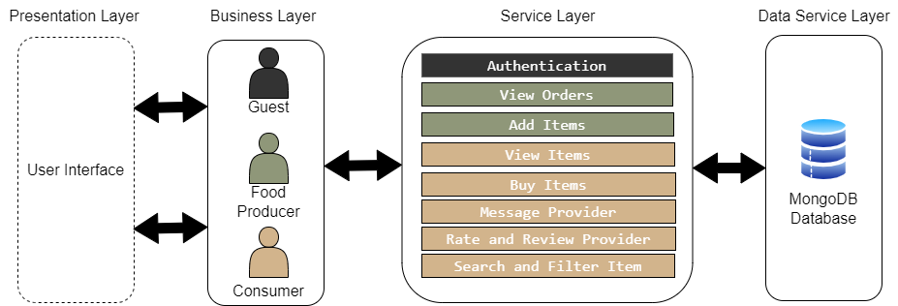

Fig 1. Architecture diagram

The design and development of the Taste of Home platform followed a robust methodology to ensure a seamless and user-friendly experience. The architecture was carefully crafted using the MERN (MongoDB, Express.js, React.js, Node.js) stack, leveraging its flexibility and scalability to accommodate the platform's diverse requirements.
At the core of the design lies the Presentation Layer, responsible for managing the intuitive user interface and facilitating seamless interactions between users and the system. This layer ensures a consistent and engaging experience across various devices and platforms.
The Business Layer orchestrates the intricate relationships and interactions between guests, food producers, and consumers within the Taste of Home ecosystem. It governs the flow of information and enforces the platform's business rules and logic.
The Service Layer encapsulates the various functionalities offered by the platform, including user authentication, order management, item listing, messaging, rating and reviewing, and advanced search and filtering capabilities. This layer serves as the backbone, providing a comprehensive set of services to enhance the overall user experience.
Underpinning the entire architecture is the Data Service Layer, powered by MongoDB, a flexible and scalable NoSQL database. This layer ensures efficient storage and retrieval of user data, item details, chat histories, and review information, enabling smooth operations and data persistence across the platform.
The methodology also placed a strong emphasis on security and data protection. Robust encryption and authentication mechanisms were implemented to safeguard user data and ensure the integrity of transactions. Furthermore, rigorous testing procedures were employed to validate the platform's functionality, performance, and usability, ensuring a high-quality experience for all stakeholders.

VI RESULT

The Taste of Home platform garnered significant traction within its initial launch phase, attracting a diverse array of local food producers eager to showcase their culinary prowess. From home bakers and chefs to small-scale catering businesses, the platform provided a level playing field for these talents to reach a broader audience. Detailed listings, coupled with high-quality images and comprehensive descriptions, enabled consumers to make informed decisions aligned with their preferences. The integrated search and filtering functionalities further streamlined the discovery process, fostering an immersive browsing experience for users seeking specific cuisines, dietary restrictions, or unique dish offerings.
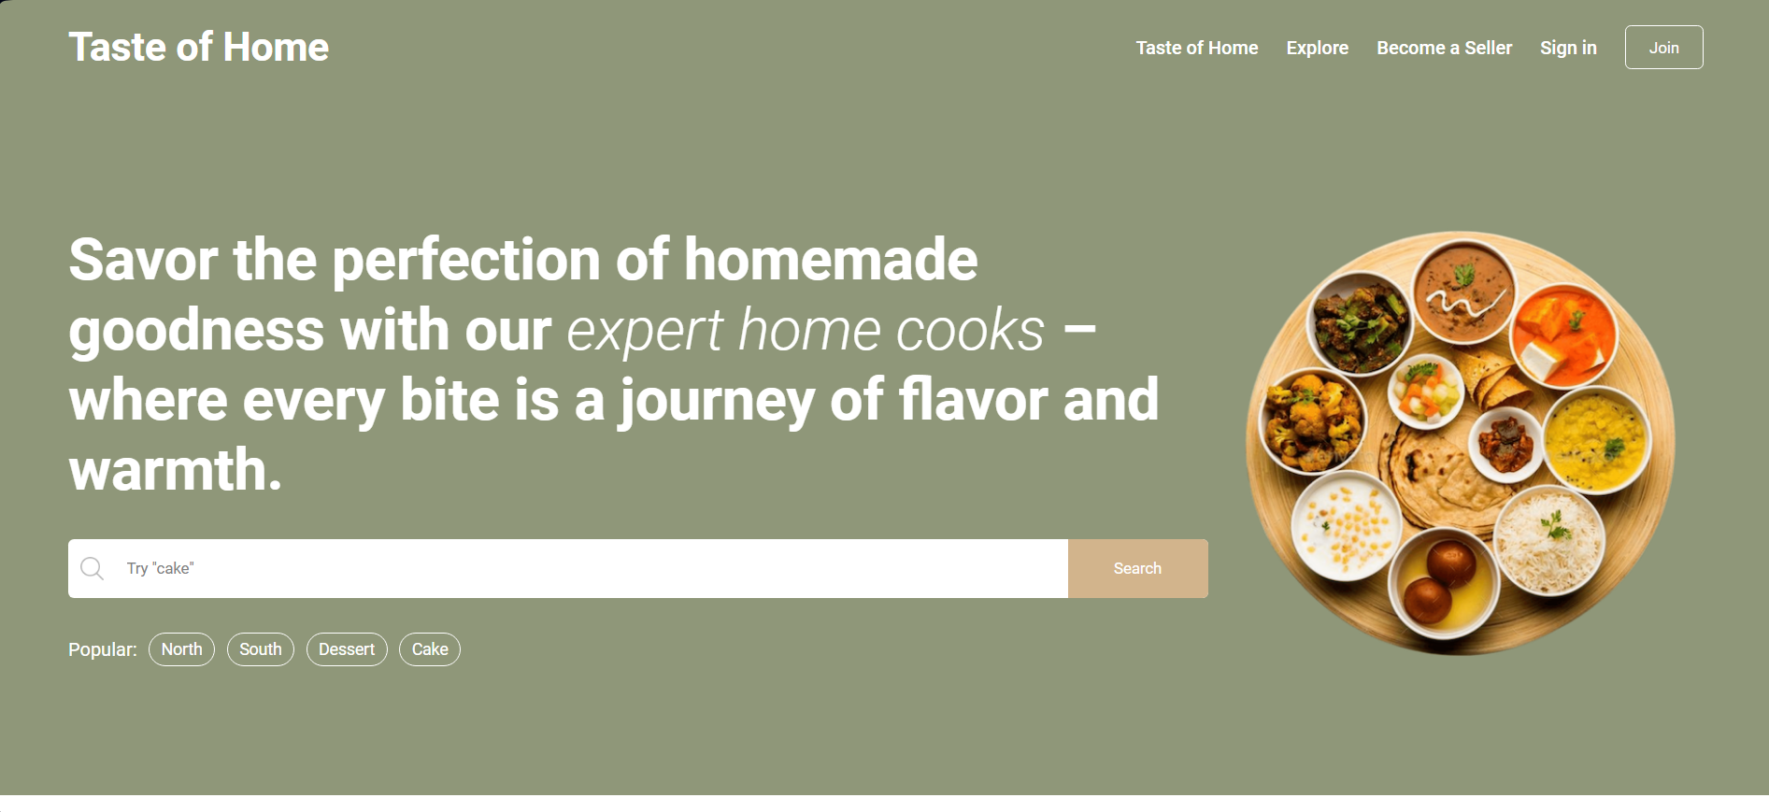
Fig 2 Home Page
Moreover, the platform's commitment to fostering a sustainable food ecosystem was evident in the substantial reduction of food waste observed among participating producers. By connecting them directly with consumers, the platform eliminated unnecessary intermediaries and optimized supply chains, ensuring that excess produce and prepared meals found their way to appreciative consumers rather than contributing to waste. This positive impact not only benefited the environment but also translated into economic advantages for local food producers, who could maximize their revenue streams while minimizing waste. The platform's user-friendly dashboards, providing comprehensive order histories and analytics, empowered producers to make informed decisions and adapt their offerings based on consumer demand patterns.

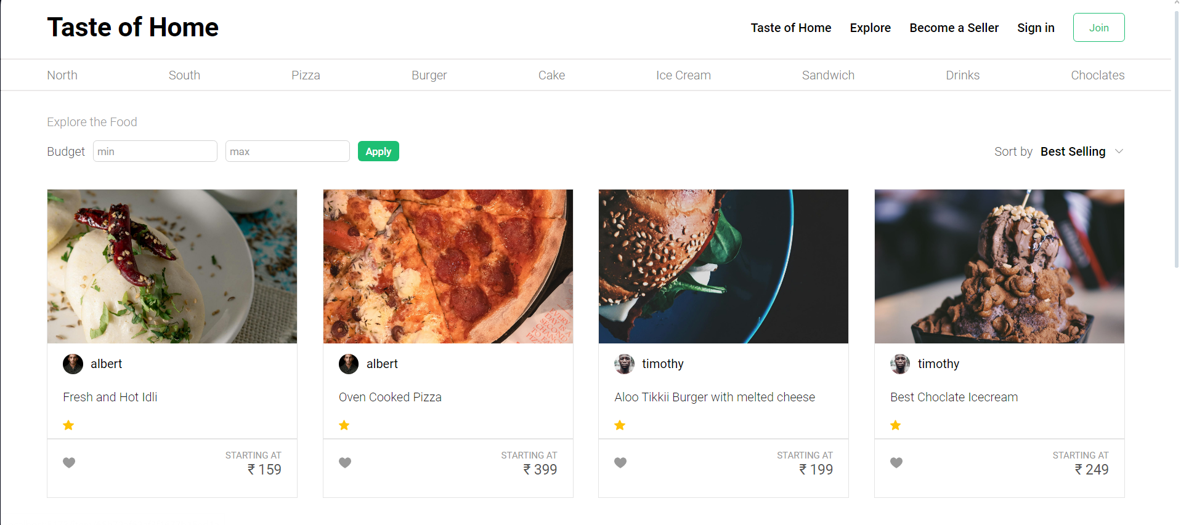

Fig 3 Explore Page

VI I CONCLUSION

In conclusion, Taste of Home stands as a testament to the transformative power of technology in reshaping the culinary landscape. Through its community-driven approach and innovative use of the MERN stack framework, the platform has successfully bridged the gap between local food producers and consumers, fostering vibrant connections and celebrating culinary diversity. By empowering small-scale producers, reducing food waste, and promoting sustainability, Taste of Home not only enhances the culinary experience but also contributes to economic growth and social cohesion within communities. As we navigate the ever-evolving digital age, Taste of Home serves as a beacon of inspiration, redefining how we experience and share homemade delights while championing the values of authenticity, community, and sustainability.

REFERENCES

- A REAL TIME WEB SERVICE SYSTEM FOR FOOD DELIVERY | Journal of Data Acquisition and Processing | 2023 | https://sjcjycl.cn/article/view-2023/pdf/02_1628.pdf
- Causal analysis of factors contributing to food wastage in restaurants of India | International Conference on Computational Intelligence and Sustainable Engineering Solutions (CISES) | 2023-12-27 | https://ieeexplore.ieee.org/document/10183615
- Food Ordering website "Cooked with care" developed using MERN stack | IEEE Xplore | 2022 | https://www.researchgate.net/publication/361178168_Food_Ordering_website_Cooked_with_care_developed_using_MERN_stack
- Web Based Application for Ordering Food Raw Materials | 1st International Conference on Computer Science and Artificial Intelligence | 2021 | https://ieeexplore.ieee.org/document/9609733
- Design of Web App for Online Food Services | International Journal for Research in Applied Science & Engineering Technology (IJRASET) | May 2022 | https://www.ijraset.com/research-paper/design-of-web-app-for-online-food-services
- E-Commerce web Application by using MERN Technology | International Journal for Modern Trends in Science and Technology | June 2021| https://www.ijmtst.com/vol7issue05.html
- MERN Stack Web Development | Annals of R.S.C.B | May 2021 | http://annalsofrscb.ro/index.php/journal
- CHALLENGES OF FOOD SECURITY | International Conference on Research in Humanities, Applied Sciences and Education| June 5th 2022| https://www.researchgate.net/publication/312093853_Challenges_of_Food_Security_in_India
- Investigating the Feasibility of a Restaurant Delivery Service to Improve Food Security among College Students Experiencing Marginal Food Security, a Head-to-Head Trial with Grocery Store Gift Cards | Int. J. Environ. Res. Public Health | 2021 | https://doi.org/10.3390/ijerph18189680
- Implementation of RESTful API Web Services Architecture in Takeaway Application Development | 1st International Conference on Electronic and Electrical Engineering and Intelligent System (ICE3IS)| 2021 | https://ieeexplore.ieee.org/document/9649679
- Solving Food Wastage issues through BYOD application | Fifth National Conference of Saudi Computers Colleges (NCCC) | 2022 | https://ieeexplore.ieee.org/document/10067735
- Review of Online Food Delivery Platforms and their Impacts on Sustainability | Fifth National Conference of Saudi Computers Colleges (NCCC) | 8 July 2020| https://ideas.repec.org/a/gam/jsusta/v12y2020i14p5528-d382021.html

